A PROJECT REPORT ON CCSA Website

Submitted to-



DIBRUGARH UNIVERSITY

*In partial fulfilment for the award of degree of*

**BACHELOR OF COMPUTER APPLICATION**

Minor Project – II

Submitted by:

Arghajit Saha, Roll No:(22992148)

And

Aditya Karmakar, Roll No:(22992147)

**CENTRE FOR COMPUTER SCIENCE AND APPLICATIONS,**

**DIBRUGARH UNIVERSITY,**

**DIBRUGARH – 786004, ASSAM, INDIA**

**BATCH 2022-2025**

**CERTIFICATE**

This is to certify that the project report entitled “**CCSA Website**” by **Arghajit Saha (Roll No- 22992148)** and **Aditya Karmakar (Roll No- 22992147)**, submitted to Dibrugarh University, Dibrugarh, Assam, in partial fulfilment of the requirements for the award of the Degree of **BACHELOR OF COMPUTER APPLICATIONS**, is a bona fide record of the project work carried out by them during **August – December** 2024.

………………………………..

**(Prof. Tazid Ali)**

Chairperson

Centre for Computer Science and Applications,

Dibrugarh University

**EXAMINATION CERTIFICATE**

This is to certify that **Arghajit Saha (22992148)** and **Aditya Karmakar (22992147)** of the Centre for Computer Science and Applications, Dibrugarh University has carried out the Project Work in a manner satisfactory to warrant its acceptance and defended it successfully. I wish them all the success in their future endeavors.

Examiners:

1. Name ……………………………. 2. Name ………………………

Signature …………………………… Signature………………….

**DECLARATION**

I hereby declare that the project work entitled **CCSA Website,** submitted to Dibrugarh University, Dibrugarh, Assam, in partial fulfillment for the minor project of 5th semester of Bachelor of Computer Applications is an original work done by Arghajit Saha (Roll no- 22992148) and Aditya Karmakar (Roll no- 22992147).

Signature of the Students:

Aditya Karmarkar

Roll no. 22992147

Arghajit Saha

Roll no 22992148

**ACKNOWLEDGEMENT**

In performing our project, we had to take the help and guideline of some respected people, who deserve our greatest gratitude. The completion of this project gives us much pleasure. We would like to show our gratitude to all the faculty members of CCSA, Dibrugarh University for giving us a good guideline for the project throughout numerous consultations.

We would also like to extend our deepest gratitude to all those who have directly and indirectly guided us in the completion of this project.

In addition, a thank you to all our professors, who introduced us to the Art of Computer Programming and their passion for the "underlying structures”, had lasting effect. We also thank the University of Dibrugarh for their consent to include copyright pictures as a part of our paper.

Many people, especially our classmates and team members, have made valuable comment suggestions on this project which gave us an inspiration to improve our application.

We thank all the people for their help directly and indirectly to complete our assignment.

Arghajit Saha (22992148)

Aditya Karmakar (22992147)

BCA 5th Semester

Centre for Computer Science and Applications

**CONTENTS**

**CERTIFICATE ii**

**EXAMINATION CERTIFICATE iii**

**DECLARATION iv**

**ACKNOWLEDGEMENT v**

**CONTENTS vi**

**1. INTRODUCTION 1**

**1.1 Problem Statements – 2**

**1.2 Objectives – 3**

**1.3 Feasibility Analysis – 4**

**2. HARDWARE AND SOFTWARE REQUIREMENTS 5**

**2.1 Software – 5**

**2.2 Operating System – 5**

**2.3 Language Used – 5**

**2.4 Hardware – 5**

**3. CONCEPTUAL MODELS 6**

**3.1 Data Flow Diagram – 6**

**3.2 Entity-Relationship Diagram – 7**

**4. SCREENSHOTS 8**

**4.1 User View – 8**

**4.2 Admin View – 11**

**5. CONCLUSION 13**

**REFERENCES vii**

# **INTRODUCTION**

CCSA Website Dibrugarh University is proud to introduce an innovative platform designed to transform the way students, faculty, and staff access, manage, and share academic resources. This advanced system replaces traditional administrative methods with a streamlined, technology-driven approach that enhances efficiency, convenience, and collaboration across the university community.

The platform enables users to browse a diverse array of educational resources, manage course materials with ease, access real-time notifications, and engage in seamless collaboration. For students, it simplifies academic management, offering tools to track progress, retrieve resources, and participate in group activities. Faculty members benefit from features that allow them to organize course content, monitor engagement, and optimize classroom management. Administrators are equipped with robust tools for managing user data, updating information dynamically, and analysing academic trends to support informed decision-making.

Designed with scalability and security in mind, the platform ensures a reliable experience while protecting sensitive information. Its user-friendly interface and responsive design make it accessible across devices, empowering users to stay productive anytime, anywhere. By fostering a connected and efficient environment, the CCSA platform aims to elevate academic excellence and operational efficiency, creating a modern and collaborative ecosystem for the university.

## **Problem Statements –**

### **Difficulty in Academic Resource Management Towards Semester-End –**

### As the semester progresses, students and faculty often face challenges in managing academic resources, leading to last-minute stress and inefficiencies. Limited time towards the end of the semester can restrict access to study materials, and increased workloads make organizing resources and preparing for evaluations difficult. Additionally, high demand for shared resources may leave fewer options for late access. Proactive planning and proper resource allocation can help mitigate these issues, but they require effort and consistency.

### **Lack of Variety and Personalization in Academic Tools -**

### Students and faculty frequently experience a lack of variety in academic tools and resources, leading to dissatisfaction. Without proper customization, users may repeatedly rely on generic materials, and standard resources may not cater to specific academic needs or preferences. Moreover, finding new and tailored resources can be time-consuming and overwhelming. The CCSA platform aims to offer personalized recommendations and a diverse range of tools to enhance academic experience.

### **Inconvenience in Tracking Academic Progress and Resources –**

### Keeping track of academic progress, resource utilization, and important milestones can be cumbersome, especially when managing multiple subjects or activities. Users may need to manually document their achievements, assignments, and accessed resources, and finding relevant information can be difficult without a centralized system.

### **Overwhelmed by Daily Academic Decisions –**

### Daily academic decisions can become overwhelming due to packed schedules that leave little time for planning and organization. Constantly deciding what to focus on or prioritize can lead to stress and suboptimal outcomes, and finding new and engaging ways to approach academic challenges requires effort and creativity. The CCSA platform aims to alleviate this burden by providing tailored recommendations and simplifying decision-making processes.

## **Objectives –**

### **To Discover New Academic Opportunities:**

### Exploring a diverse range of resources, courses, and tools helps students and faculty expand their knowledge and skills, enhancing the overall learning and teaching experience.

### **To Simplify Academic Resource Management:**

### Prioritizing and organizing academic materials ensures users spend less time searching for resources, allowing them to focus on learning or teaching without the hassle of daily planning.

### **To Save Time and Effort:**

### Utilizing the CCSA platform saves time and effort by providing centralized access to study materials, notifications, and academic tools, enabling users to stay productive and efficient.

### **To Cater to Specific Academic Needs:**

### The CCSA platform allows users to easily find and utilize resources that cater to specific academic goals, preferences, or requirements, ensuring personalized and effective learning experiences.

### **To Facilitate Collaborative Academic Activities:**

### Coordinating group projects, discussions, or academic events becomes seamless with CCSA's collaborative tools and features, making teamwork and resource sharing hassle-free.

## **Feasibility Analysis** –

### **Technical Feasibility:**

### CCSA Dibrugarh University's platform will leverage available technical resources to build a robust and scalable academic management system. This includes utilizing cloud-based infrastructure for reliable performance, employing advanced algorithms for personalized academic recommendations, and ensuring seamless integration with various institutional tools and databases. The development team will prioritize a user-friendly interface and responsive design to ensure accessibility across different devices, from desktops to mobile phones.

### **Operational Feasibility:**

### The platform will allow students, faculty, and administrators to easily access, manage, and share academic resources, streamlining academic operations. Users will have tools to track their progress, set academic preferences, and receive personalized recommendations for resources and activities. By simplifying resource management and providing diverse academic tools, the platform will enhance user satisfaction and reduce the time and effort spent on daily academic decisions. Additionally, collaborative features will improve operational efficiency in coordinating group projects, discussions, and institutional activities.

### **Economic Feasibility:**

### Implementing the CCSA platform will involve initial development costs, ongoing maintenance, and training expenses. However, the platform is designed to provide significant value to both students and faculty. For students, it offers convenient access to resources, reducing the need for expensive supplementary materials. For the university, the platform can optimize resource allocation, increase institutional efficiency, and potentially attract more enrollments due to its advanced capabilities. The economic feasibility of the platform is supported by its potential to streamline academic processes, reduce operational overheads, and create value for all stakeholders.

# **HARDWARE AND SOFTWARE REQUIREMENTS**

## **Software** –

### **Visual Studio Code**

### **Xampp Server**

## **Operating System** –

### **Windows 11**

## **Language Used** –

### **HTML**

### **Tailwind CSS CDN**

### **Alpine JS**

### **Javascript**

### **PHP**

### **MySQL (Database Tool)**

## **Hardware** –

### **Processor:** AMD RYZEN 7

### **RAM:** 8GB

### **Graphics Card:** RTX 3050

### **SSD:** 512GB

# **CONCEPTUAL MODELS**

## **Data Flow Diagram –**

### **0 Level / Context Diagram –**

### **Level 1 DFD –**

### **A diagram of a software development**

## **Entity-Relationship Diagram –**

# **SCREENSHOTS**

## **User View –**

### **Home Page –**

### **Create Account Page –**

### **About Us –**

### **Chairperson Message –**

### **FAQ –**

### **Contact –**

## **Admin View –**

### **Dashboard –**

### **All Teaching Staff –**

### **Notifications –**

### **Uploads –**

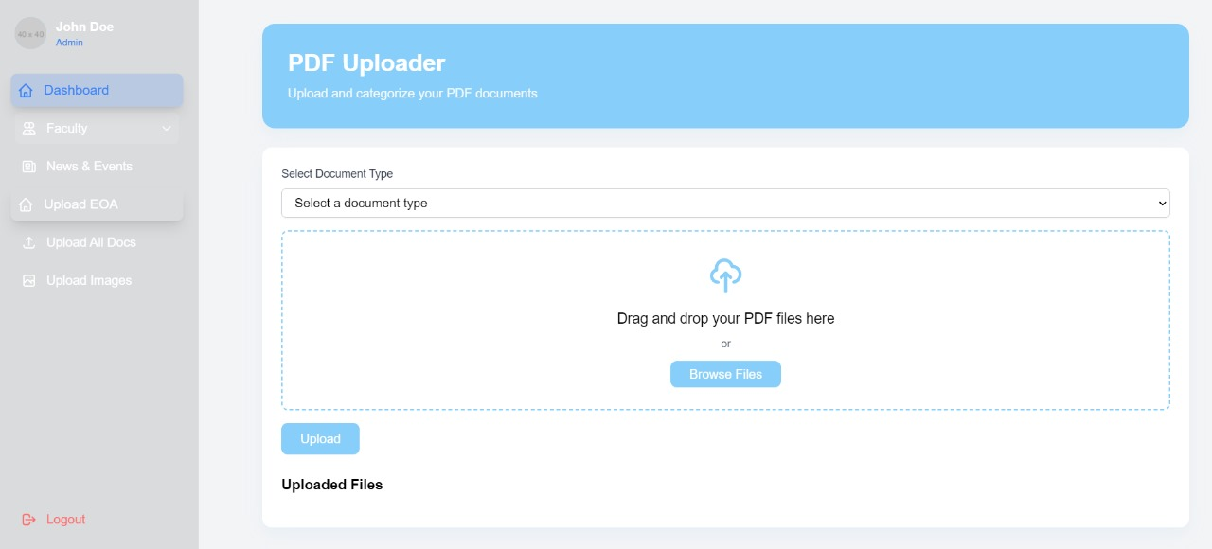

# **CONCLUSION**

In conclusion, the development of the CCSA Website platform for Dibrugarh University has been an invaluable learning experience, resulting in a robust and user-friendly system that effectively addresses the academic needs of students, faculty, and administrators. By leveraging modern technologies and employing best practices in software development, we have created a scalable and maintainable platform that streamlines resource management, enhances user engagement, and provides valuable insights through comprehensive data analytics. The platform's intuitive interface, personalized recommendations, and seamless integration across various devices ensure that users can easily access, manage, and utilize academic resources anytime, anywhere. As the project comes to an end, we are confident that the CCSA platform will contribute to improved academic efficiency, collaboration, and satisfaction for all stakeholders, ultimately leading to better educational outcomes and institutional growth. We are proud of the work accomplished and look forward to the positive impact this platform will have on the academic community.

**REFERENCES**

1. ChatGPT
2. <https://youtu.be/gXWohFYrI0M?si=GH3DFr4bp9u2FkMm>
3. <https://youtu.be/1SnPKhCdlsU?si=ANsiaggBKTeeBb5U>
4. <http://www.youtube.com/@CodeAstro>
5. Claude Ai
6. Source Code: <https://github.com/Adk2002/CCSA>
7. Live website Link: http://www.ccsdu.in/